**CSA4737-Deep Learning for Climate Prediction**

**Name: G. Lakshman**

**Reg No:192324069**

**Experiment 1:**

**Aim:** To demonstrate confusion matrix using python

**Program:**

import numpy as np

from sklearn.metrics import confusion_matrix

import seaborn as sns

import matplotlib.pyplot as plt

actual    = np.array(

  ['Dog','Dog','Dog','Not Dog','Dog','Not Dog','Dog','Dog','Not Dog','Not Dog'])

predicted = np.array(

  ['Dog','Not Dog','Dog','Not Dog','Dog','Dog','Dog','Dog','Not Dog','Not Dog'])

conf_matrix=confusion_matrix(actual,predicted)

sns.heatmap(conf_matrix,annot=True,fmt='g',xticklabels=['Dog','Not Dog'],yticklabels=['Dog','Not Dog'],cmap='RdPu')

plt.ylabel("prediction",fontsize=16)

plt.xlabel("actual",fontsize=16)

plt.title("confusion matrix",fontsize=20)

plt.show()

**Output:**

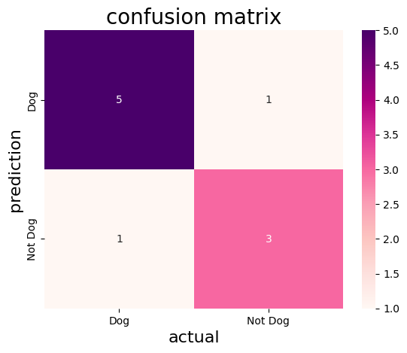

**Experiment 2:**

**Aim:** To demonstrate 2 class confusion matrix using python

**Program:**

import pandas as pd

import matplotlib.pyplot as plt

import seaborn as sns

from sklearn.datasets import load_wine

from sklearn.model_selection import train_test_split

from sklearn.tree import DecisionTreeClassifier

from sklearn.metrics import accuracy_score,f1_score,precision_score,recall_score,classification_report,confusion_matrix

wine=load_wine()

data=pd.DataFrame(data=wine.data,columns=wine.feature_names)

data['Target']=wine.target

data=data[data['Target']!=2]

x=data.drop('Target',axis=1)

y=data['Target']

x_train,x_test,y_train,y_test=train_test_split(x,y,test_size=0.3,random_state=1)

model=DecisionTreeClassifier(random_state=1)

model.fit(x_train,y_train)

y_pred=model.predict(x_test)

accuracy=accuracy_score(y_test,y_pred)

print("accuracy:",accuracy)

class_report = classification_report(y_test, y_pred, target_names=wine.target_names[:2])

print("Classification Report:\n", class_report)

precision = precision_score(y_test, y_pred)

recall = recall_score(y_test, y_pred)

f1 = f1_score(y_test, y_pred)

print(f"Precision: {precision:.2f}")

print(f"Recall: {recall:.2f}")

print(f"F1 Score: {f1:.2f}")

conf_matrix=confusion_matrix(y_test,y_pred)

plt.figure(figsize=(8,6))

sns.heatmap(conf_matrix,annot=True,fmt='d',cmap='PuBuGn',xticklabels=wine.target_names[:2],yticklabels=wine.target_names[:2])

plt.xlabel("predicted label")

plt.ylabel("true label")

plt.title("confusion matrix")

plt.show()

**Output:**

accuracy: 0.9743589743589743

Classification Report:

precision recall f1-score support

class_0 1.00 0.94 0.97 17

class_1 0.96 1.00 0.98 22

accuracy 0.97 39

macro avg 0.98 0.97 0.97 39

weighted avg 0.98 0.97 0.97 39

Precision: 0.96

Recall: 1.00

F1 Score: 0.98

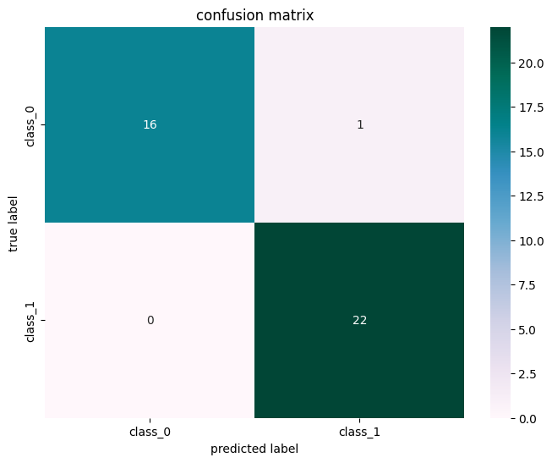

**Experiment 3:**

**Aim:** To analyse the performance of a multi class confusion matrix by using choosen database with python code

**Program:**

from sklearn.datasets import load_digits

from sklearn.model_selection import train_test_split

from sklearn.ensemble import RandomForestClassifier

from sklearn.metrics import confusion_matrix

import seaborn as sns

import matplotlib.pyplot as plt

from sklearn.metrics import accuracy_score, precision_score, recall_score, f1_score

X, y= load_digits(return_X_y=True)

X_train, X_test, y_train, y_test = train_test_split(X, y,test_size=0.25)

clf = RandomForestClassifier(random_state=23)

clf.fit(X_train, y_train)

y_pred = clf.predict(X_test)

cm = confusion_matrix(y_test,y_pred)

sns.heatmap(cm,

            annot=True,

            fmt='g',cmap="winter")

plt.ylabel('Prediction',fontsize=13)

plt.xlabel('Actual',fontsize=13)

plt.title('Confusion Matrix',fontsize=17)

plt.show()

accuracy = accuracy_score(y_test, y_pred)

print("Accuracy   :", accuracy)

**Output:**

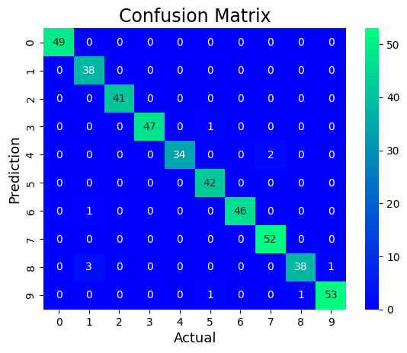

Accuracy : 0.9777777777777777

**Experiment 4:**

**Aim:** To analyse the performance of a over fitting by using choosen database with python code

**Program:**

import numpy as np

import matplotlib.pyplot as plt

from sklearn.pipeline import Pipeline

from sklearn.preprocessing import PolynomialFeatures

from sklearn.linear_model import LinearRegression

from sklearn.model_selection import cross_val_score

def true_fun(X):

    return np.cos(1.5 * np.pi * X)

np.random.seed(0)

n_samples = 30

degrees = [1, 4, 15]

X = np.sort(np.random.rand(n_samples))

y = true_fun(X) + np.random.randn(n_samples) * 0.1

plt.figure(figsize=(14, 5))

for i in range(len(degrees)):

    ax = plt.subplot(1, len(degrees), i + 1)

    plt.setp(ax, xticks=(), yticks=())

    polynomial_features = PolynomialFeatures(degree=degrees[i], include_bias=False)

    linear_regression = LinearRegression()

    pipeline = Pipeline(

        [

            ("polynomial_features", polynomial_features),

            ("linear_regression", linear_regression),

        ]

    )

    pipeline.fit(X[:, np.newaxis], y)

    scores = cross_val_score(

        pipeline, X[:, np.newaxis], y, scoring="neg_mean_squared_error", cv=10

    )

    X_test = np.linspace(0, 1, 100)

    plt.plot(X_test, pipeline.predict(X_test[:, np.newaxis]), label="Model")

    plt.plot(X_test, true_fun(X_test), label="True function")

    plt.scatter(X, y, edgecolor="y", s=20,marker="^", label="Samples")

    plt.xlabel("x")

    plt.ylabel("y")

    plt.xlim((0, 1))

    plt.ylim((-2, 2))

    plt.legend(loc="best")

    plt.title(

        "Degree {}\nMSE = {:.2e}(+/- {:.2e})".format(

            degrees[i], -scores.mean(), scores.std()

        )

    )

plt.show()

**Output:**

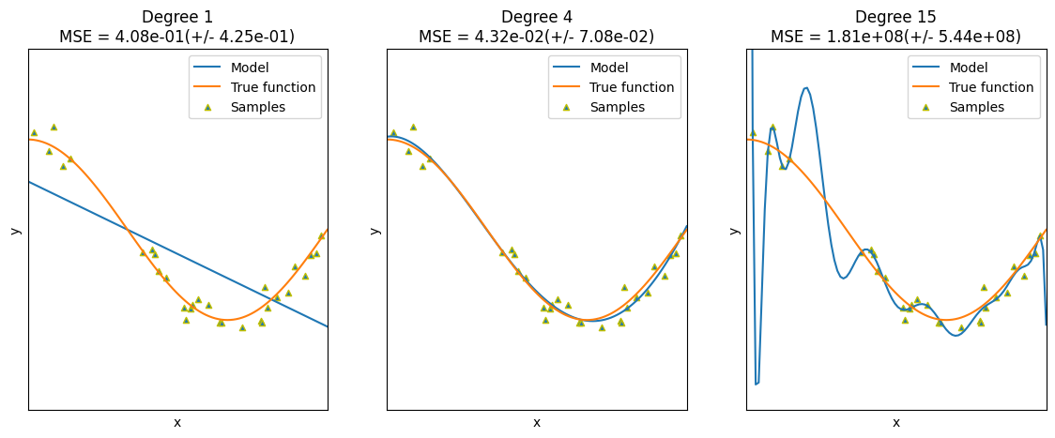

**Experiment 5:**

**Aim:** To demonstrate the performance of a linear regression by using choosen database with python code

**Program:**

import pandas as pd

import matplotlib.pyplot as plt

from sklearn.datasets import load_iris

from sklearn.model_selection import train_test_split

from sklearn.linear_model import LinearRegression

from sklearn.metrics import mean_squared_error

iris = load_iris()

data = pd.DataFrame(data=iris.data, columns=iris.feature_names)

data['species'] = iris.target

print(data.head())

X = data[['sepal length (cm)']]

y = data['sepal width (cm)']

X_train, X_test, y_train, y_test = train_test_split(X, y, test_size=0.3, random_state=42)

model = LinearRegression()

model.fit(X_train, y_train)

y_pred = model.predict(X_test)

mse = mean_squared_error(y_test, y_pred)

print(f'Mean Squared Error on test set: {mse:.2f}')

plt.figure(figsize=(10, 6))

plt.scatter(X_test, y_test, color='r',marker='*', label='Actual')

plt.plot(X_test, y_pred, color='y', linewidth=3, label='Predicted')

plt.xlabel('Sepal Length (cm)')

plt.ylabel('Sepal Width (cm)')

plt.title('Linear Regression: Sepal Width vs Sepal Length')

plt.legend()

plt.show()

new_sample = pd.DataFrame([[5]], columns=['sepal length (cm)'])

predicted_width = model.predict(new_sample)

print(f'The predicted sepal width for sepal length {new_sample.values.tolist()} is {predicted_width[0]:.2f} cm')

**Output:**

Mean Squared Error on test set: 0.23

The predicted sepal width for sepal length [[5]] is 3.02 cm

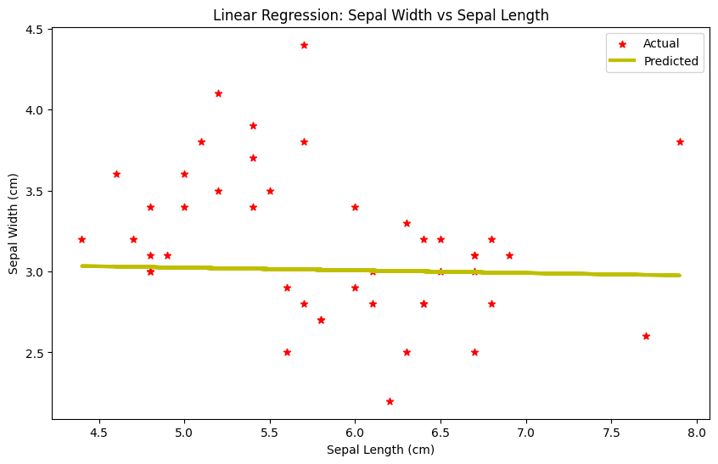

**Experiment 6:**

**Aim:** To demonstrate the performance of knn using wine dataset

**Program:**

import pandas as pd

import pandas as pd

import matplotlib.pyplot as plt

import seaborn as sns

from sklearn.datasets import load_wine

from sklearn.model_selection import train_test_split

from sklearn.neighbors import KNeighborsClassifier

from sklearn.metrics import accuracy_score,confusion_matrix

wine=load_wine()

data=pd.DataFrame(data=wine.data,columns=wine.feature_names)

data['Target']=wine.target

x=data.drop('Target',axis=1)

y=data['Target']

x_train,x_test,y_train,y_test=train_test_split(x,y,test_size=0.3,random_state=1)

model=KNeighborsClassifier(n_neighbors=5)

model.fit(x_train,y_train)

y_pred=model.predict(x_test)

accuracy=accuracy_score(y_test,y_pred)

print("accuracy:",accuracy)

conf_matrix = confusion_matrix(y_test,y_pred)

plt.figure(figsize=(8, 6))

sns.heatmap(conf_matrix, annot=True, fmt='d', cmap='summer', xticklabels=wine.target_names, yticklabels=wine.target_names)

plt.xlabel('Predicted Label')

plt.ylabel('True Label')

plt.title('Confusion Matrix')

plt.show()

**Output:**

accuracy: 0.7037037037037037

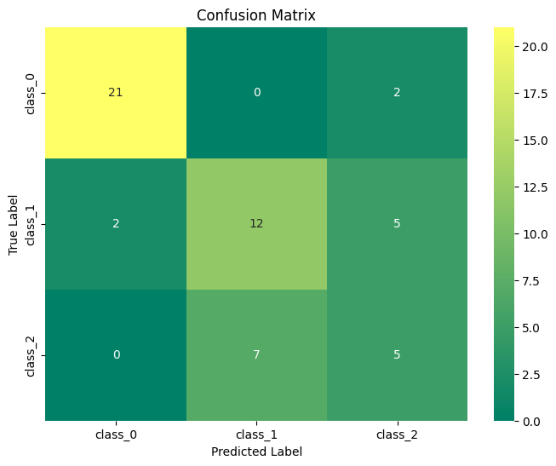

**Experiment 7:**

**Aim:** To demonstrate the performance of a logistic regression by using choosen database with python code.

**Program:**

import numpy as np

import matplotlib.pyplot as plt

def sigmoid(z):

    return 1 / (1 + np.exp( - z))

plt.plot(np.arange(-5, 5, 0.1), sigmoid(np.arange(-5, 5, 0.1)),color='pink')

plt.title('Visualization of the Sigmoid Function')

plt.show()

**Output:**

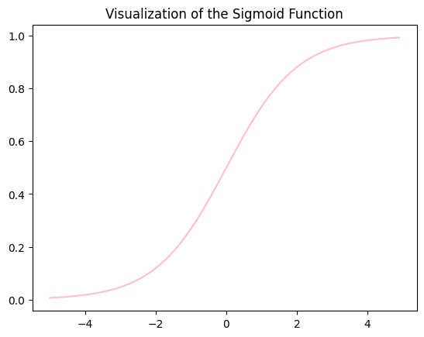

**Experiment 8:**

**Aim:** To demonstrate the performance of KNN algorithm by using iris dataset

**Program:**

import pandas as pd

import matplotlib.pyplot as plt

import seaborn as sns

from sklearn.datasets import load_iris

from sklearn.model_selection import train_test_split

from sklearn.neighbors import KNeighborsClassifier

from sklearn.metrics import accuracy_score,confusion_matrix

iris=load_iris()

data=pd.DataFrame(data=iris.data,columns=iris.feature_names)

data['Species']=iris.target

x=data.drop('Species',axis=1)

y=data['Species']

x_train,x_test,y_train,y_test=train_test_split(x,y,test_size=0.3,random_state=1)

model=KNeighborsClassifier(n_neighbors=5)

model.fit(x_train,y_train)

y_pred=model.predict(x_test)

accuracy=accuracy_score(y_test,y_pred)

print("accuracy:",accuracy)

conf_matrix = confusion_matrix(y_test,y_pred)

plt.figure(figsize=(8, 6))

sns.heatmap(conf_matrix, annot=True, fmt='d', cmap='pink', xticklabels=iris.target_names, yticklabels=iris.target_names)

plt.xlabel('Predicted Label')

plt.ylabel('True Label')

plt.title('Confusion Matrix')

plt.show()

**Output:**

accuracy: 0.9777777777777777

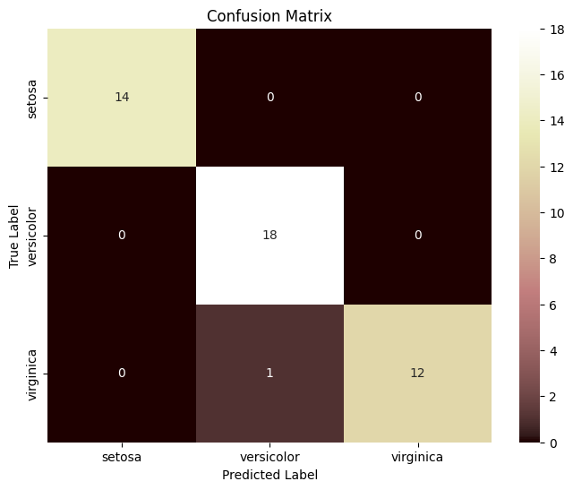

**Experiment 9:**

**Aim: :** To demonstrate the performance of Naïve Bayes algorithm by using iris dataset

**Program:**

#naive bayes iris

import pandas as pd

import matplotlib.pyplot as plt

import seaborn as sns

from sklearn.datasets import load_iris

from sklearn.model_selection import train_test_split

from sklearn.naive_bayes import GaussianNB

from sklearn.metrics import accuracy_score,confusion_matrix

iris = load_iris()

data = pd.DataFrame(data=iris.data, columns=iris.feature_names)

data['species'] = iris.target

X = data.drop('species', axis=1)

y = data['species']

X_train, X_test, y_train, y_test = train_test_split(X, y, test_size=0.3, random_state=42)

model = GaussianNB()

model.fit(X_train, y_train)

y_pred = model.predict(X_test)

accuracy = accuracy_score(y_test, y_pred)

print("accuracy:",accuracy)

conf_matrix = confusion_matrix(y_test,y_pred)

plt.figure(figsize=(8, 6))

sns.heatmap(conf_matrix, annot=True, fmt='d', cmap='vanimo', xticklabels=iris.target_names, yticklabels=iris.target_names)

plt.xlabel('Predicted Label')

plt.ylabel('True Label')

plt.title('Confusion Matrix')

plt.show()

**Output:**

accuracy: 0.9777777777777777

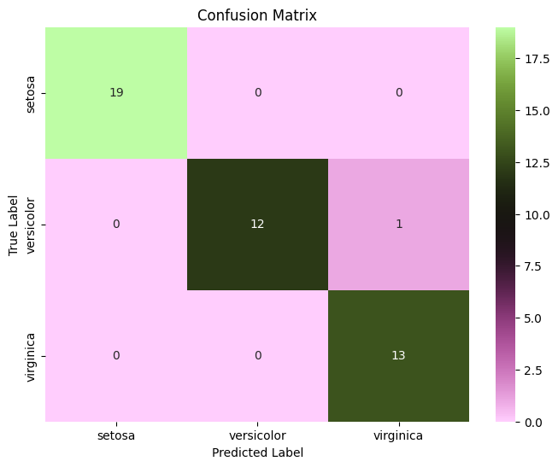

**Experiment 10:**

**Aim:** To demonstrate the performance of Logistic Regression using iris dataset

**Program:**

import pandas as pd

import matplotlib.pyplot as plt

import seaborn as sns

from sklearn.datasets import load_iris

from sklearn.model_selection import train_test_split

from sklearn.linear_model import LogisticRegression

from sklearn.metrics import accuracy_score,confusion_matrix

iris = load_iris()

data = pd.DataFrame(data=iris.data, columns=iris.feature_names)

data['species'] = iris.target

X = data.drop('species', axis=1)

y = data['species']

X_train, X_test, y_train, y_test = train_test_split(X, y, test_size=0.2, random_state=1)

model =LogisticRegression(max_iter=200)

model.fit(X_train, y_train)

y_pred = model.predict(X_test)

accuracy = accuracy_score(y_test, y_pred)

print("accuracy:",accuracy)

conf_matrix = confusion_matrix(y_test,y_pred)

plt.figure(figsize=(8, 6))

sns.heatmap(conf_matrix, annot=True, fmt='d', cmap='berlin', xticklabels=iris.target_names, yticklabels=iris.target_names)

plt.xlabel('Predicted Label')

plt.ylabel('True Label')

plt.title('Confusion Matrix')

plt.show()

**Output:**

accuracy: 0.9666666666666667

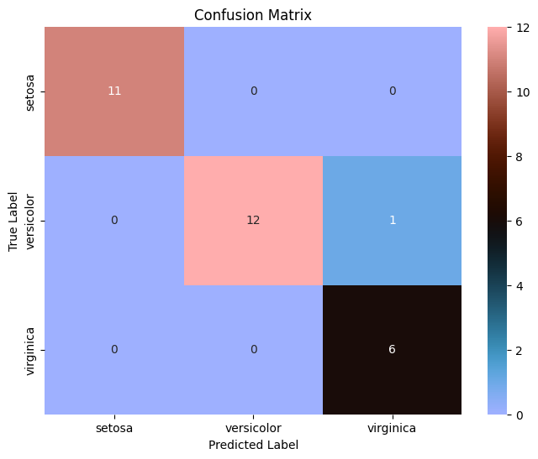

**Experiment 11:**

**Aim:** To demonstrate the performance of Decision tree Classifier algorithm using iris dataset.

**Program:**

import pandas as pd

import matplotlib.pyplot as plt

import seaborn as sns

from sklearn.datasets import load_iris

from sklearn.model_selection import train_test_split

from sklearn.tree import DecisionTreeClassifier

from sklearn.metrics import accuracy_score,confusion_matrix

iris = load_iris()

data = pd.DataFrame(data=iris.data, columns=iris.feature_names)

data['species'] = iris.target

X = data.drop('species', axis=1)

y = data['species']

X_train, X_test, y_train, y_test = train_test_split(X, y, test_size=0.2, random_state=1)

model =DecisionTreeClassifier()

model.fit(X_train, y_train)

y_pred = model.predict(X_test)

accuracy = accuracy_score(y_test, y_pred)

print("accuracy:",accuracy)

conf_matrix = confusion_matrix(y_test,y_pred)

plt.figure(figsize=(8, 6))

sns.heatmap(conf_matrix, annot=True, fmt='d', cmap='PRGn', xticklabels=iris.target_names, yticklabels=iris.target_names)

plt.xlabel('Predicted Label')

plt.ylabel('True Label')

plt.title('Confusion Matrix')

plt.show()

**Output:**

accuracy: 0.9666666666666667

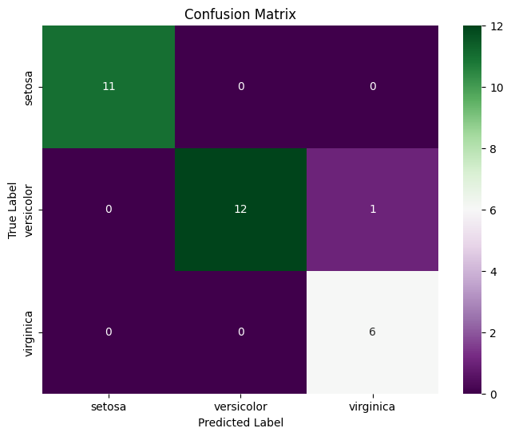

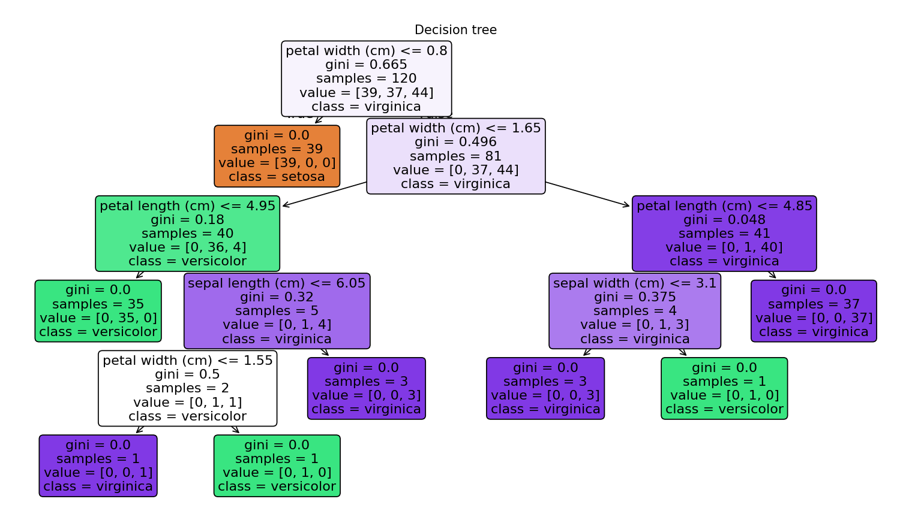

**Experiment 12:**

**Aim:** To demonstrate the performance of Random Forest classifier algorithm by using iris dataset

**Program:**

import pandas as pd

import matplotlib.pyplot as plt

import seaborn as sns

from sklearn.datasets import load_iris

from sklearn.model_selection import train_test_split

from sklearn.ensemble import RandomForestClassifier

from sklearn.metrics import accuracy_score,confusion_matrix

iris=load_iris()

data=pd.DataFrame(data=iris.data,columns=iris.feature_names)

data['Species']=iris.target

x=data.drop('Species',axis=1)

y=data['Species']

x_train,x_test,y_train,y_test=train_test_split(x,y,test_size=0.3,random_state=1)

model=RandomForestClassifier(n_estimators=100,random_state=1)

model.fit(x_train,y_train)

y_pred=model.predict(x_test)

accuracy=accuracy_score(y_test,y_pred)

print("accuracy:",accuracy)

conf_matrix = confusion_matrix(y_test,y_pred)

plt.figure(figsize=(8, 6))

sns.heatmap(conf_matrix, annot=True, fmt='d', cmap='managua', xticklabels=iris.target_names, yticklabels=iris.target_names)

plt.xlabel('Predicted Label')

plt.ylabel('True Label')

plt.title('Confusion Matrix')

plt.show()

**Output:**

accuracy: 0.9555555555555556

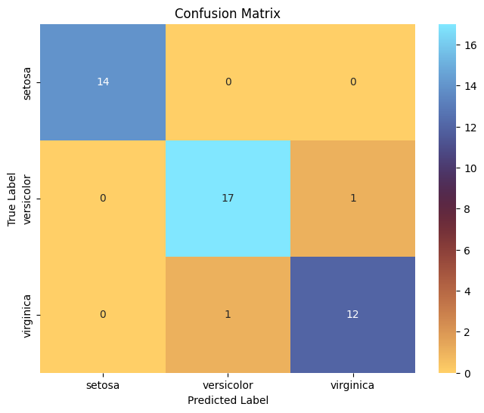

**Experiment 13:**

**Aim:** To demonstrate the performance of SVM algorithm by using iris dataset

**Program:**

import pandas as pd

import matplotlib.pyplot as plt

import seaborn as sns

from sklearn.datasets import load_iris

from sklearn.model_selection import train_test_split

from sklearn.svm import SVC

from sklearn.metrics import accuracy_score,confusion_matrix

iris=load_iris()

data=pd.DataFrame(data=iris.data,columns=iris.feature_names)

data['Species']=iris.target

x=data.drop('Species',axis=1)

y=data['Species']

x_train,x_test,y_train,y_test=train_test_split(x,y,test_size=0.2,random_state=1)

model=SVC(kernel='poly',random_state=1)

model.fit(x_train,y_train)

y_pred=model.predict(x_test)

accuracy=accuracy_score(y_test,y_pred)

print("accuracy:",accuracy)

conf_matrix = confusion_matrix(y_test,y_pred)

plt.figure(figsize=(8, 6))

sns.heatmap(conf_matrix, annot=True, fmt='d', cmap='turbo', xticklabels=iris.target_names, yticklabels=iris.target_names)

plt.xlabel('Predicted Label')

plt.ylabel('True Label')

plt.title('Confusion Matrix')

plt.show()

**Output:**

accuracy: 0.9666666666666667

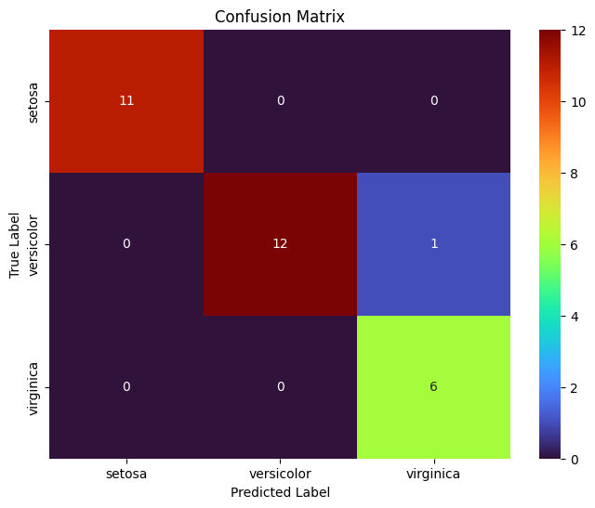

**Experiment 14:**

**Aim:** To demonstrate the gradient descent

**Program:**

import numpy as np

import matplotlib.pyplot as plt

from sklearn.preprocessing import StandardScaler

def mean_squared_error(y_true, y_predicted):

    cost = np.sum((y_true - y_predicted)**2) / len(y_true)

    return cost

def gradient_descent(x, y, iterations=1000, learning_rate=0.01, stopping_threshold=1e-6):

    current_weight = 0.0

    current_bias = 0.0

    n = float(len(x))

    costs = []

    previous_cost = None

    for i in range(iterations):

        y_predicted = current_weight * x + current_bias

        current_cost = mean_squared_error(y, y_predicted)

        if previous_cost and abs(previous_cost - current_cost) <= stopping_threshold:

            break

        previous_cost = current_cost

        costs.append(current_cost)

        weight_derivative = -(2/n) * sum(x * (y - y_predicted))

        bias_derivative = -(2/n) * sum(y - y_predicted)

        current_weight = current_weight - learning_rate * weight_derivative

        current_bias = current_bias - learning_rate * bias_derivative

        if i % 100 == 0:

            print(f"Iteration {i+1}: Cost {current_cost}, Weight {current_weight}, Bias {current_bias}")

    plt.figure(figsize=(8,6))

    plt.plot(range(len(costs)), costs, 'r.')

    plt.title("Cost vs Iterations")

    plt.xlabel("Iterations")

    plt.ylabel("Cost")

    plt.show()

    return current_weight, current_bias

def main():

    X = np.array([32.5, 53.4, 61.5, 47.4, 59.8, 55.1, 52.2, 39.2, 48.1, 52.5, 45.4, 54.3, 44.1, 58.1, 56.7, 48.9, 44.6, 60.2, 45.6, 38.8])

    Y = np.array([31.7, 68.7, 62.5, 71.5, 87.2, 78.2, 79.6, 59.1, 75.3, 71.3, 55.1, 82.4, 62.0, 75.3, 81.4, 60.7, 82.8, 97.3, 48.8, 56.8])

    scaler = StandardScaler()

    X_normalized = scaler.fit_transform(X.reshape(-1, 1)).flatten()

    estimated_weight, estimated_bias = gradient_descent(X_normalized, Y, iterations=2000, learning_rate=0.01)

    print(f"Estimated Weight: {estimated_weight}, Estimated Bias: {estimated_bias}")

    Y_pred = estimated_weight * X_normalized + estimated_bias

    plt.figure(figsize=(8,6))

    plt.scatter(X, Y, color='black', label='Data Points',marker='*')

    plt.plot(X, Y_pred, color='red', linestyle='--', label='Fitted Line')

    plt.xlabel("X")

    plt.ylabel("Y")

    plt.title("Linear Regression using Gradient Descent")

    plt.legend()

    plt.show()

if __name__ == "__main__":

    main()

**Output:**

Iteration 1: Cost 5031.3015, Weight 0.21744528996901658, Bias 1.3877

Iteration 101: Cost 185.56941123866557, Weight 9.459227106883091, Bias 60.3672282719577

Iteration 201: Cost 100.34293399589959, Weight 10.684868107118445, Bias 68.18906711826675

Iteration 301: Cost 98.84397526476002, Weight 10.847412072256065, Bias 69.22639591234459

Iteration 401: Cost 98.81761165863254, Weight 10.868968580725983, Bias 69.36396599633204

Estimated Weight: 10.87151030998278, Estimated Bias: 69.38018689350649

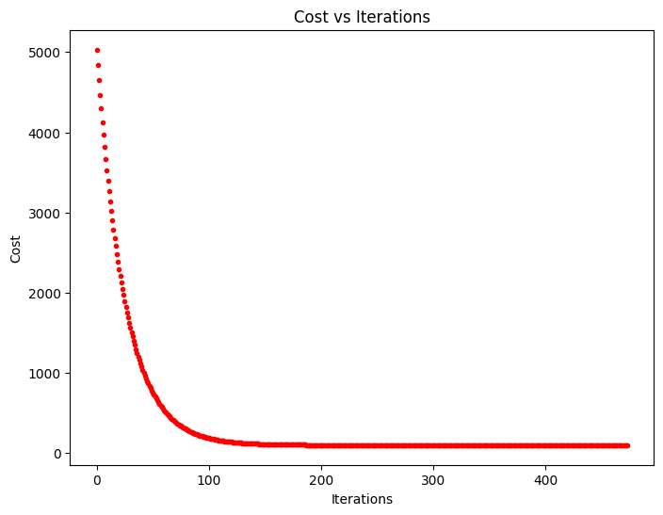

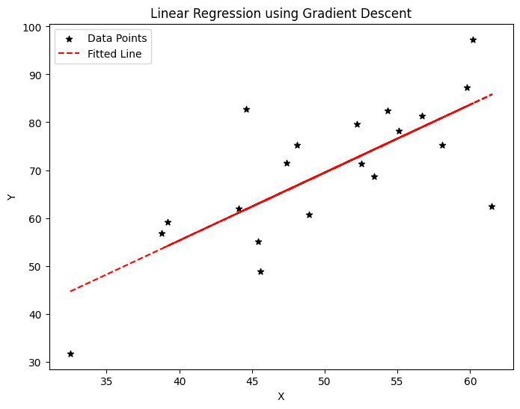

**Experiment 15:**

**Aim:** To demonstrate the segmentation of image using python

**Program:**

import cv2

import numpy as np

from matplotlib import pyplot as plt

img = cv2.imread('C:\desktop\core project\dataset\cataract\_16_1907643.jpg')

rgb_img = cv2.cvtColor(img, cv2.COLOR_BGR2RGB)

pixels = rgb_img.reshape((-1, 3))

pixels = np.float32(pixels)

criteria = (cv2.TERM_CRITERIA_EPS + cv2.TERM_CRITERIA_MAX_ITER, 100, 0.2)

K = 3

_, labels, centers = cv2.kmeans(pixels, K, None, criteria, 10, cv2.KMEANS_RANDOM_CENTERS)

centers = np.uint8(centers)

segmented_img = centers[labels.flatten()]

segmented_img = segmented_img.reshape(rgb_img.shape)

plt.figure(figsize=(10, 5))

plt.subplot(121)

plt.imshow(rgb_img)

plt.title('Original Image')

plt.axis('off')

plt.subplot(122)

plt.imshow(segmented_img)

plt.title('Segmented Image (K-means)')

plt.axis('off')

plt.tight_layout()

plt.show()

**Output:**

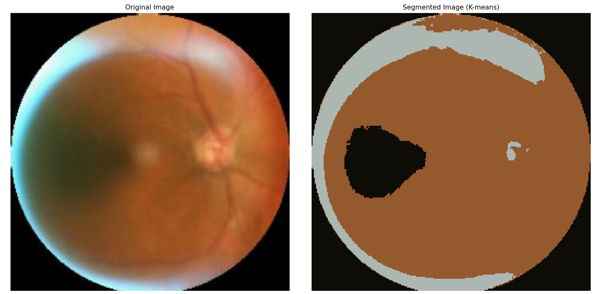

**Experiment 16:**

**Aim:** To demonstrate the segmentation of image using python

**Program:**

import numpy as np

import cv2

from matplotlib import pyplot as plt

img = cv2.imread(r'C:\desktop\core project\dataset\cataract\_16_1907643.jpg')

b, g, r = cv2.split(img)

rgb_img = cv2.merge([r, g, b])

gray = cv2.cvtColor(img, cv2.COLOR_BGR2GRAY)

ret, thresh = cv2.threshold(gray, 0, 255, cv2.THRESH_BINARY_INV + cv2.THRESH_OTSU)

kernel = np.ones((2, 2), np.uint8)

closing = cv2.morphologyEx(thresh, cv2.MORPH_CLOSE, kernel, iterations=2)

sure_bg = cv2.dilate(closing, kernel, iterations=3)

plt.figure(figsize=(12, 8))

plt.subplot(231)

plt.imshow(rgb_img)

plt.title("Original Image")

plt.xticks([]), plt.yticks([])

plt.subplot(232)

plt.imshow(gray, 'gray')

plt.title("Grayscale Image")

plt.xticks([]), plt.yticks([])

plt.subplot(233)

plt.imshow(thresh, 'gray')

plt.title("Otsu's Threshold")

plt.xticks([]), plt.yticks([])

plt.subplot(234)

plt.imshow(closing, 'gray')

plt.title("MorphologyEx: Closing (2x2)")

plt.xticks([]), plt.yticks([])

plt.subplot(235)

plt.imshow(sure_bg, 'gray')

plt.title("Dilation")

plt.xticks([]), plt.yticks([])

plt.tight_layout()

plt.show()

plt.imsave(r'dilation.png', sure_bg)

**Output:**

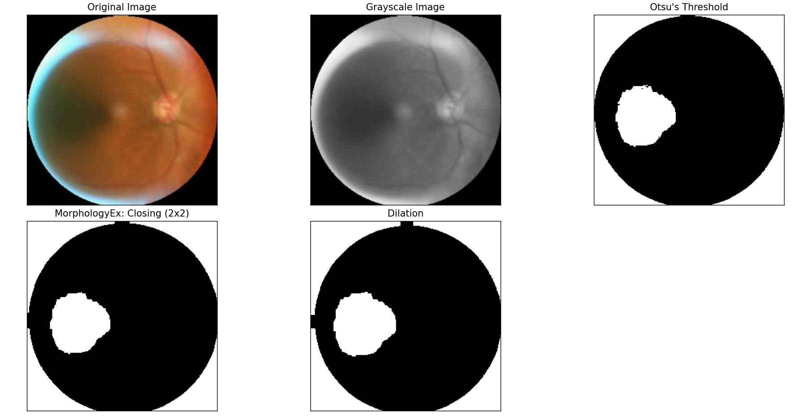

**Experiment 17:**

**Aim:** To demonstrate linear separability using python code

**Program:**

import numpy as np

import matplotlib.pyplot as plt

from sklearn.datasets import make_classification

from sklearn.linear_model import LogisticRegression

from sklearn.metrics import accuracy_score

X, y = make_classification(n_samples=100, n_features=2, n_informative=2, n_redundant=0, n_clusters_per_class=1, random_state=42)

model = LogisticRegression()

model.fit(X, y)

y_pred = model.predict(X)

accuracy = accuracy_score(y, y_pred)

print(f"Accuracy: {accuracy:.2f}")

plt.figure(figsize=(10, 6))

plt.scatter(X[:, 0], X[:, 1], c=y, cmap='berlin', edgecolor='m', s=50)

coef = model.coef_[0]

intercept = model.intercept_

x_vals = np.linspace(X[:, 0].min(), X[:, 0].max(), 100)

y_vals = - (coef[0] * x_vals + intercept) / coef[1]

plt.plot(x_vals, y_vals, 'k--')

plt.xlabel('Feature 1')

plt.ylabel('Feature 2')

plt.title('Linear Separability Demonstration')

plt.show()

i

**Output:**

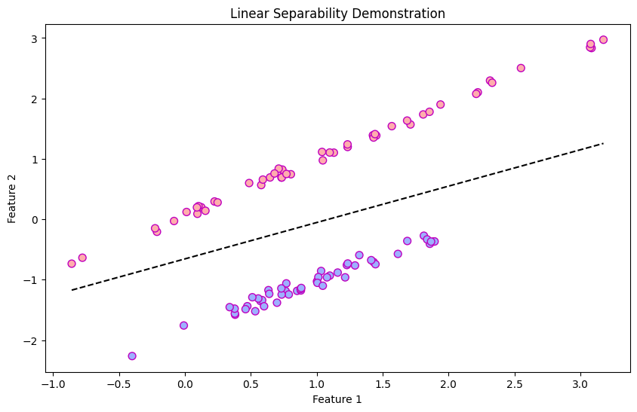

**Experiment 18:**

**Aim:** Neural network analysis for Two class, Learning rate: 0.03, Activation: Linear, Hidden Layers: 02, and Hidden neurons: 03.

**Output:**

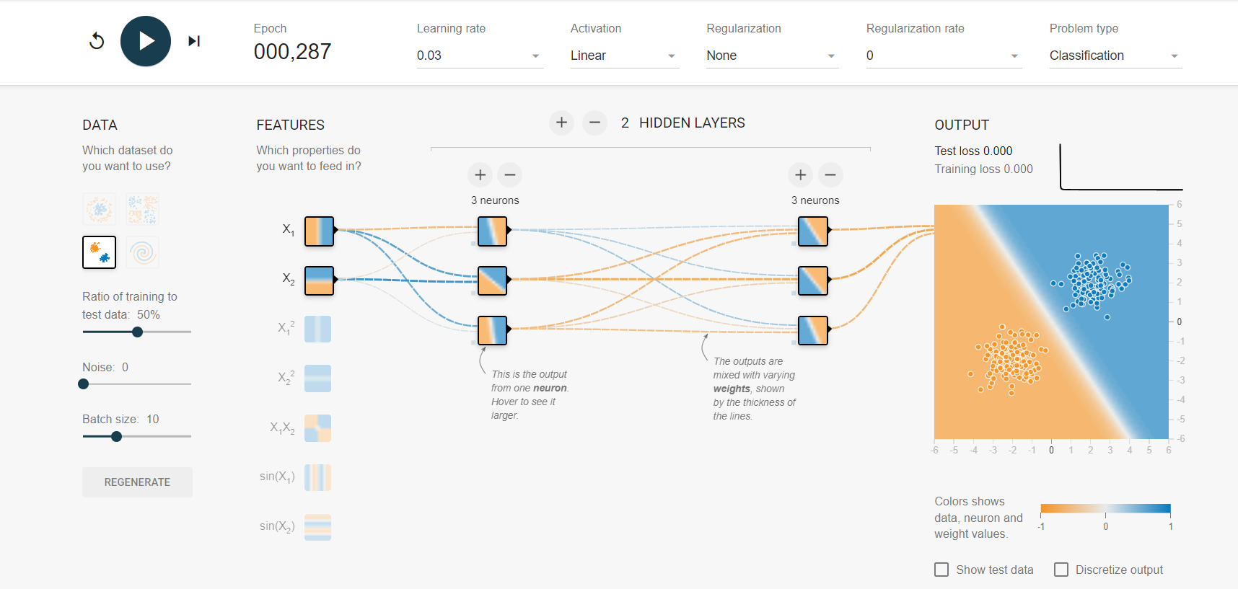

**Experiment 19:**

**Aim:** Neural network analysis for circular data class, Learning rate: 0.03, Activation: Linear, Hidden Layers: 02, and Hidden neurons: 03.

**Output:**

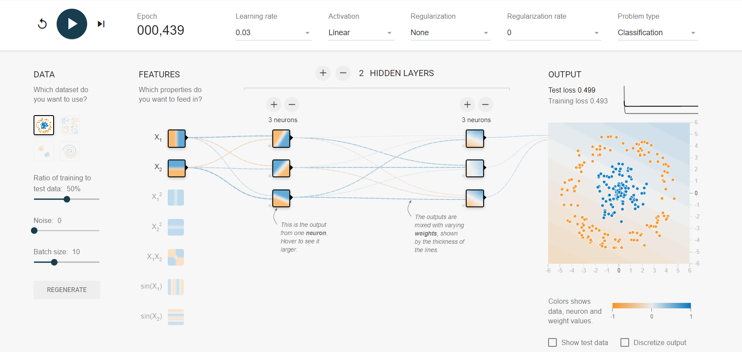

**Experiment 20:**

**Aim:** Neural network analysis for Multi class, Learning rate: 0.01, Activation: Linear, Hidden Layers: 02, and Hidden neurons: 02

**Output:**

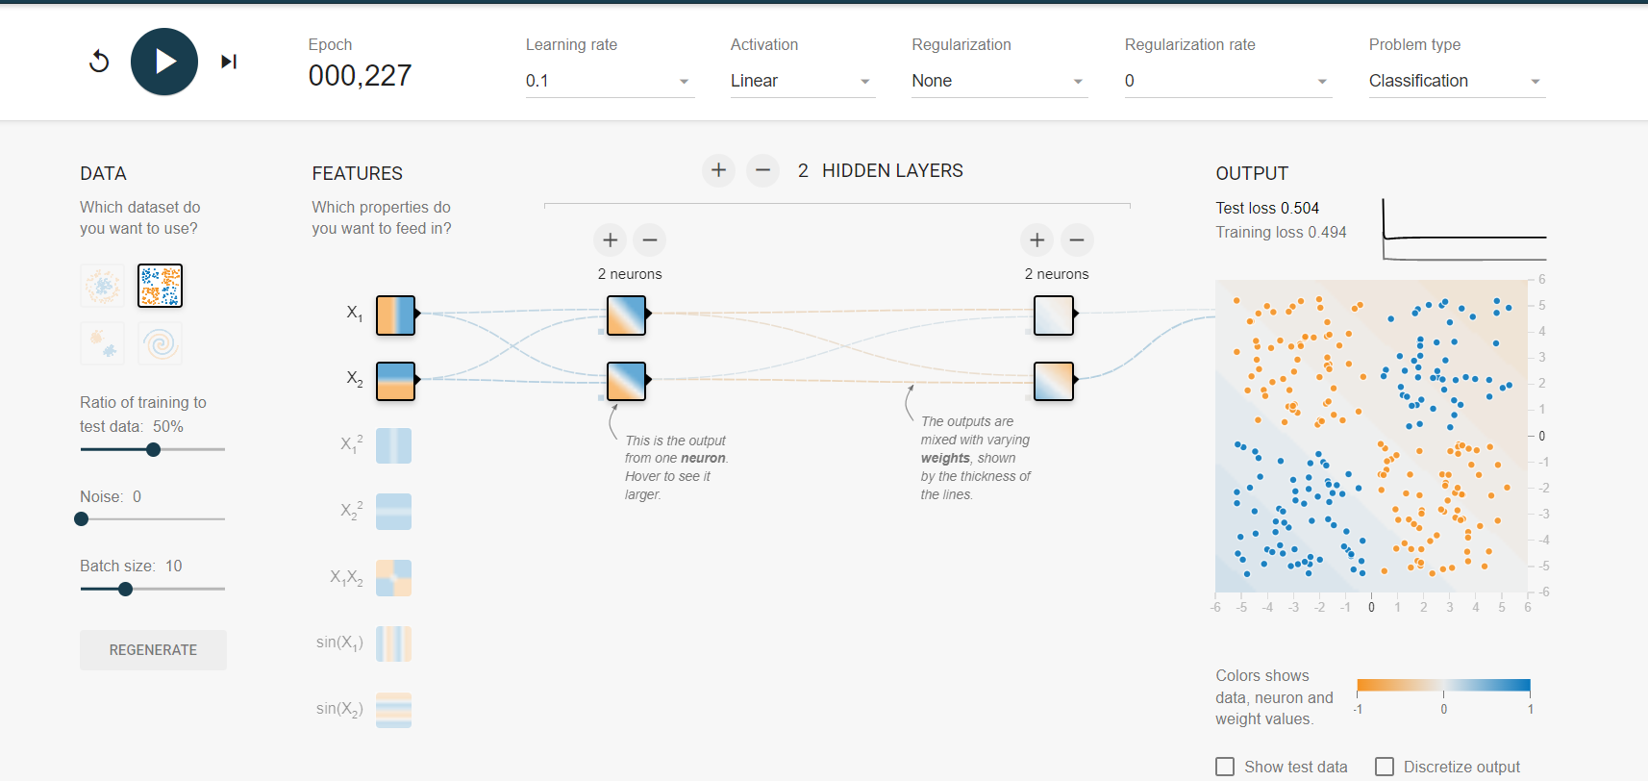

**Experiment 21:**

**Aim:** Neural network analysis forCircular data, Learning rate: 0.1, Activation: ReLU, Hidden Layers: 03, and Hidden neurons: 02.

**Output:**

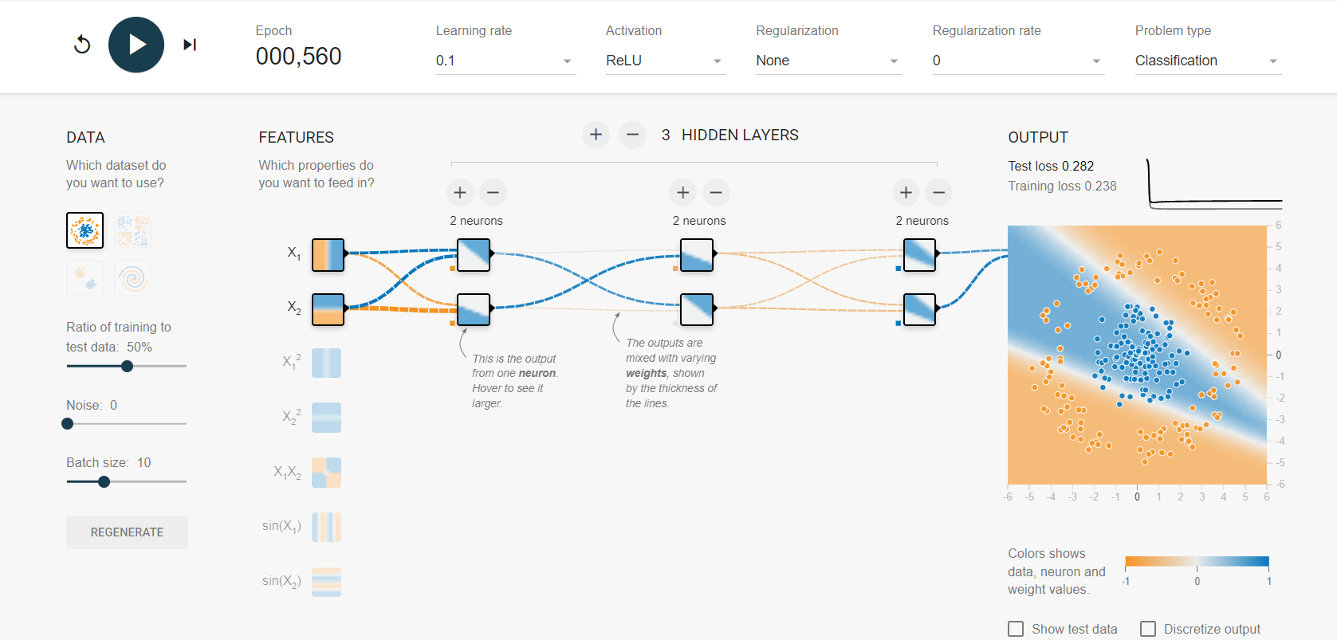

**Experiment 22:**

**Aim:** Neural network analysis fortwo class data, Learning rate: 0.1, Activation: ReLU, Hidden Layers: 03, and Hidden neurons: 02.

**Output:**

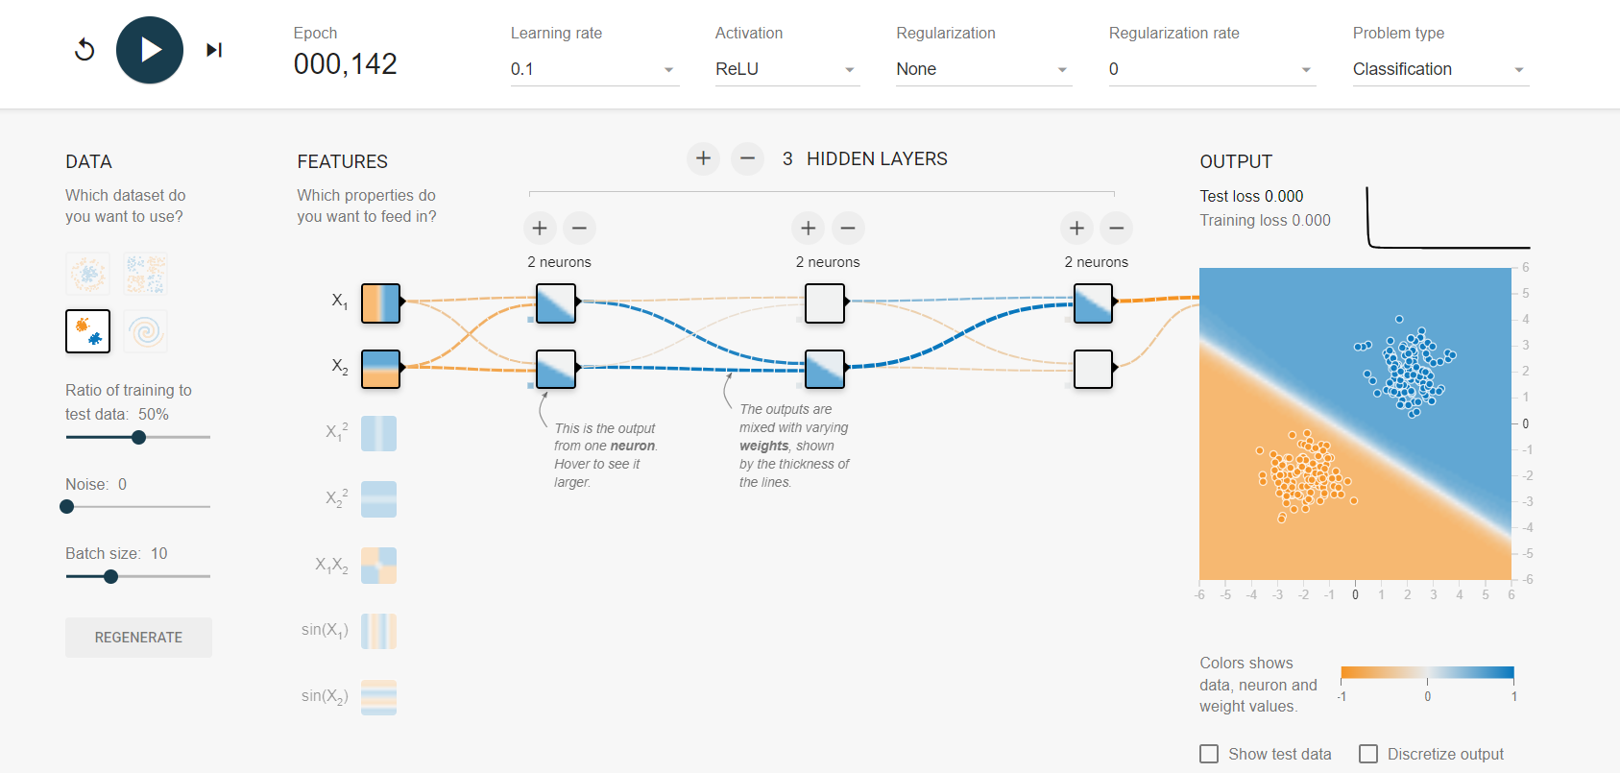

**Experiment 23:**

**Aim:** Neural network analysis forSpiral data, Learning rate: 0.1, Activation: Sigmoid, Hidden Layers: 03, and Hidden neurons: 03.

**Output:**

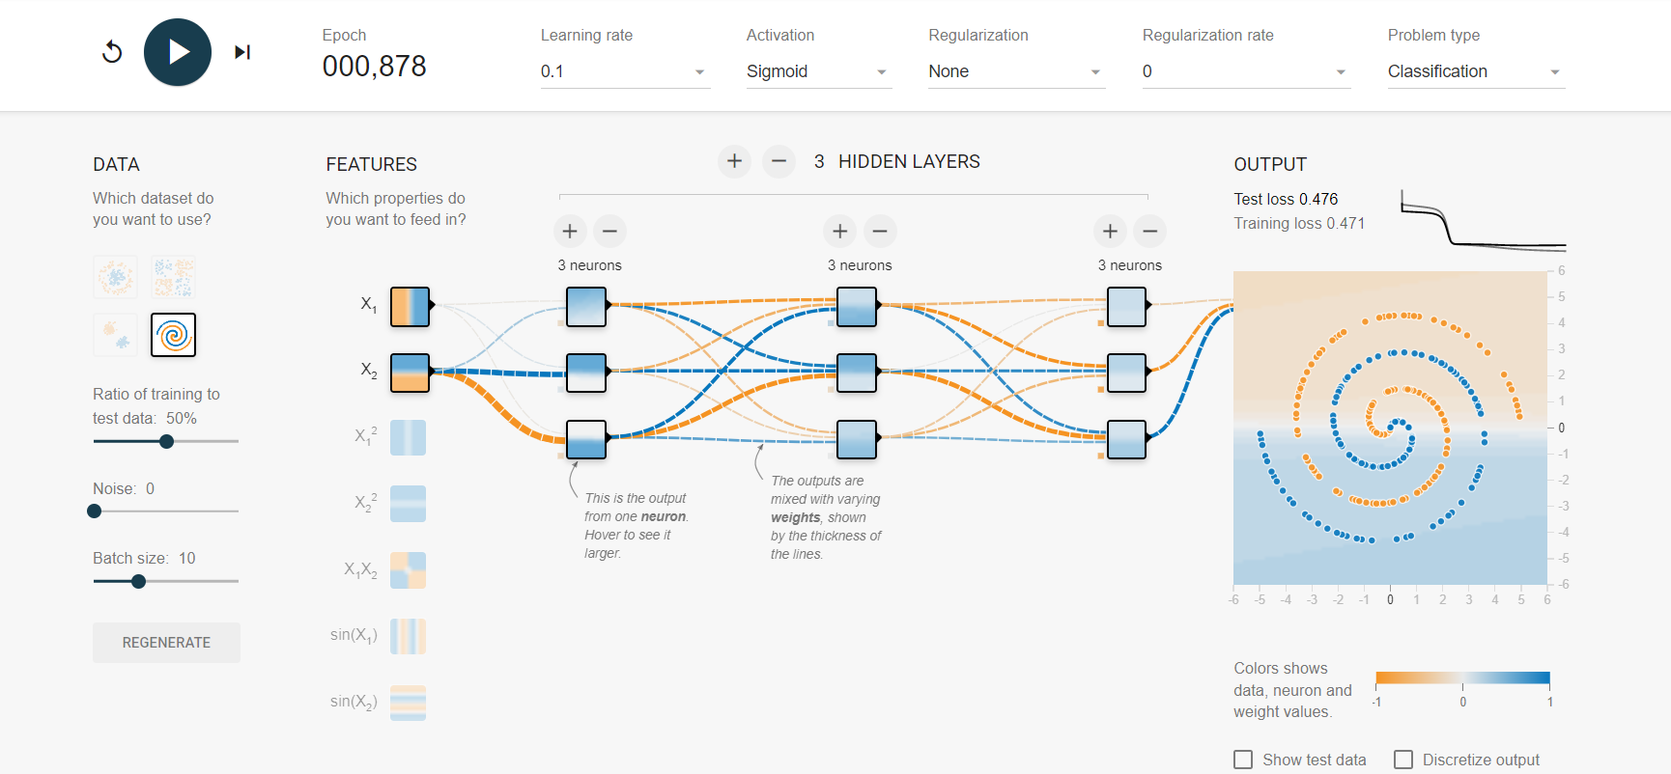

**Experiment 24:**

**Aim:** Neural network analysis formulti class data, Learning rate: 0.1, Activation: Sigmoid, Hidden Layers: 03, and Hidden neurons: 03.

**Output:**

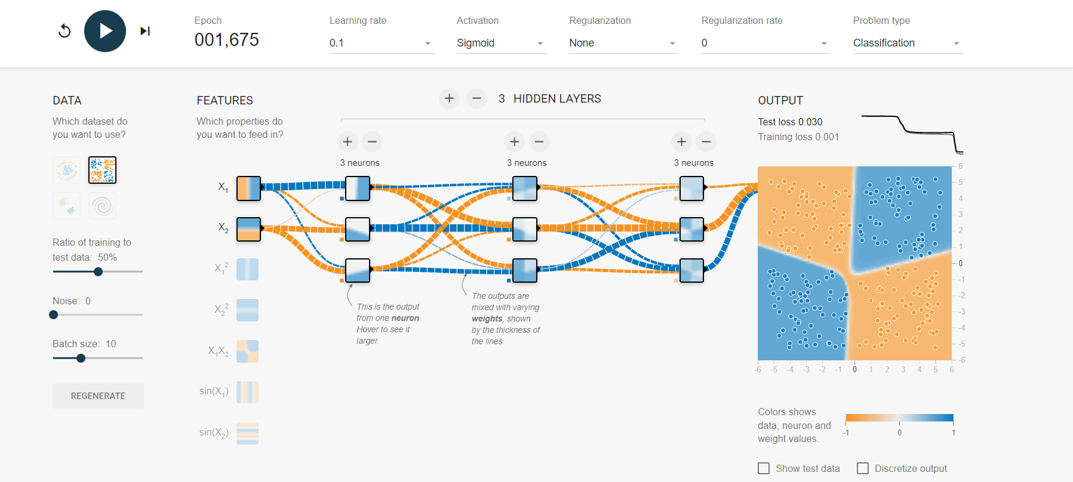

**Experiment 25:**

**Aim:** Neural network analysis for Circular data, Learning rate: 0.1, Activation: Tanh, Hidden Layers: 02, and Hidden neurons: 02.

**Output:**

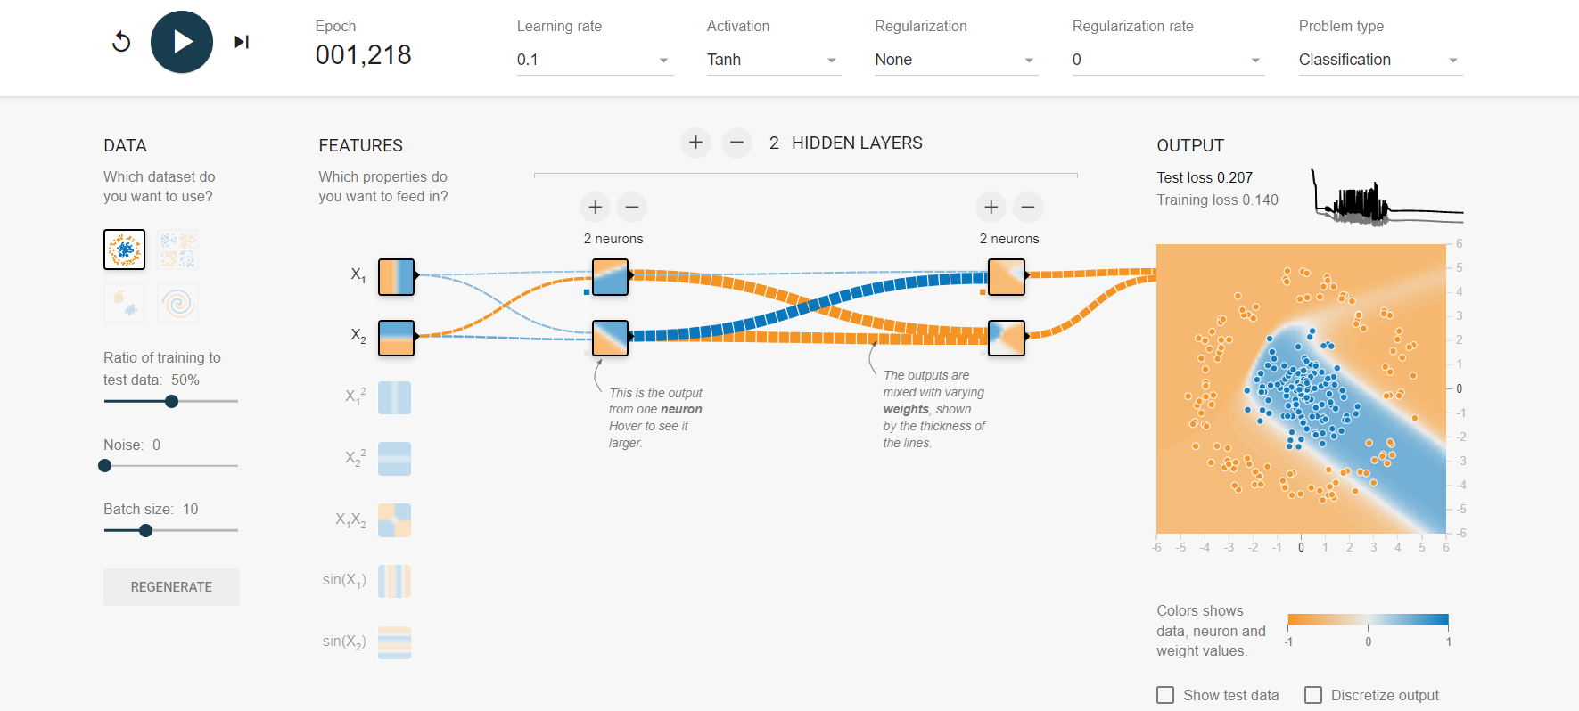

**Experiment 26:**

**Aim:** Neural network analysis for multi class data, Learning rate: 0.1, Activation: Tanh, Hidden Layers: 02, and Hidden neurons: 02.

**Output:**

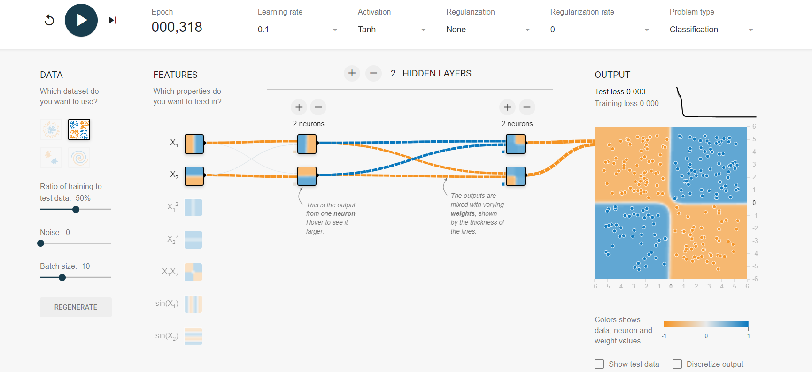

**Experiment 27:**

**Aim:** Neural network analysis for Two-class data, Learning rate: 0.001, Activation: ReLU, Hidden Layers: 03, and Hidden neurons: 02.

**Output:**

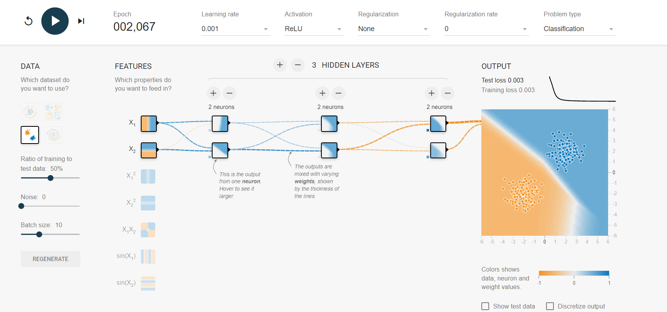

**Experiment 28:**

**Aim:** Neural network analysis for Multi class data, Learning rate: 0.001, Activation: ReLU, Hidden Layers: 03, and Hidden neurons: 02.

**Output:**

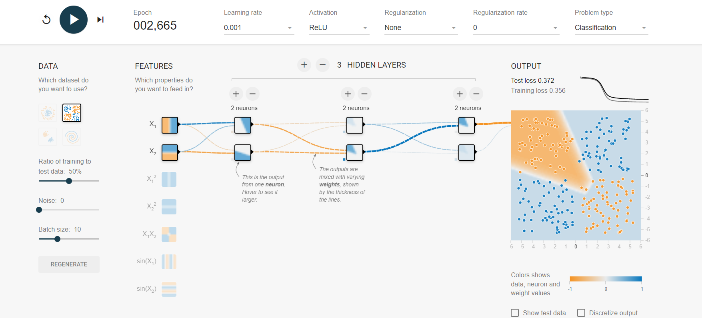

**Experiment 29:**

**Aim:** Neural network analysis for Multi-class data, Learning rate: 0.1, Activation: TanH, Hidden Layers: 03, and Hidden neurons: 03.

**Output:**

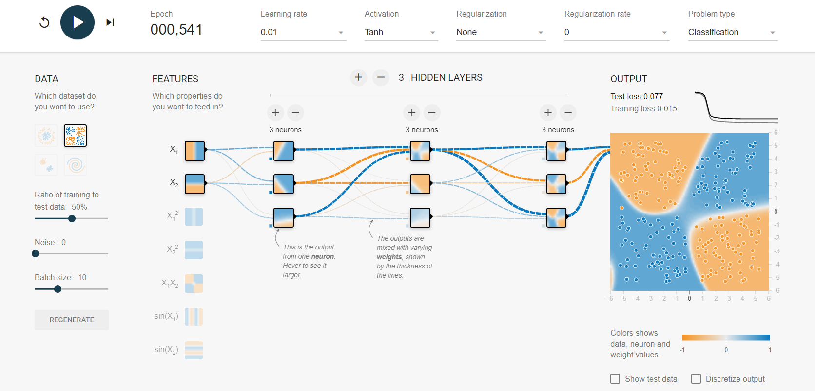

**Experiment 30:**

**Aim:** Neural network analysis for Two class data, Learning rate: 0.1, Activation: TanH, Hidden Layers: 03, and Hidden neurons: 03.

**Output:**

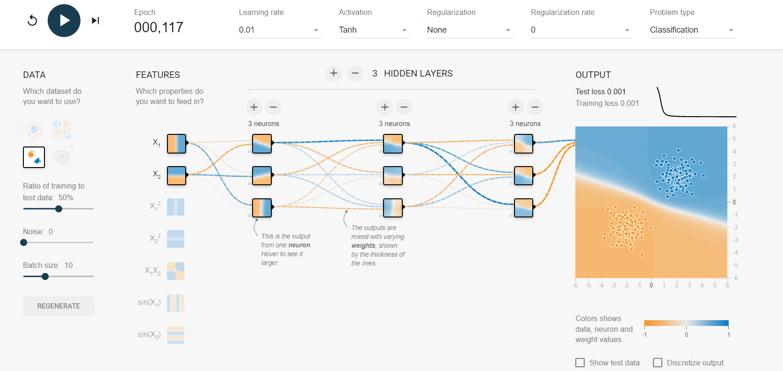

**Experiment 31:**

**Aim:** Neural network analysis for Multi-class data, Learning rate: 0.03, Activation: ReLu, Hidden Layers: 03, and Hidden neurons: 03.

**Output:**

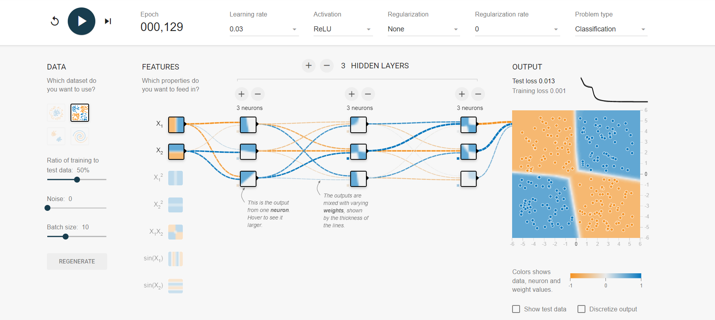

**Experiment 32:**

**Aim:** Neural network analysis for Two circular data, Learning rate: 0.1, Activation: TanH, Hidden Layers: 03, and Hidden neurons: 03.

**Output:**

